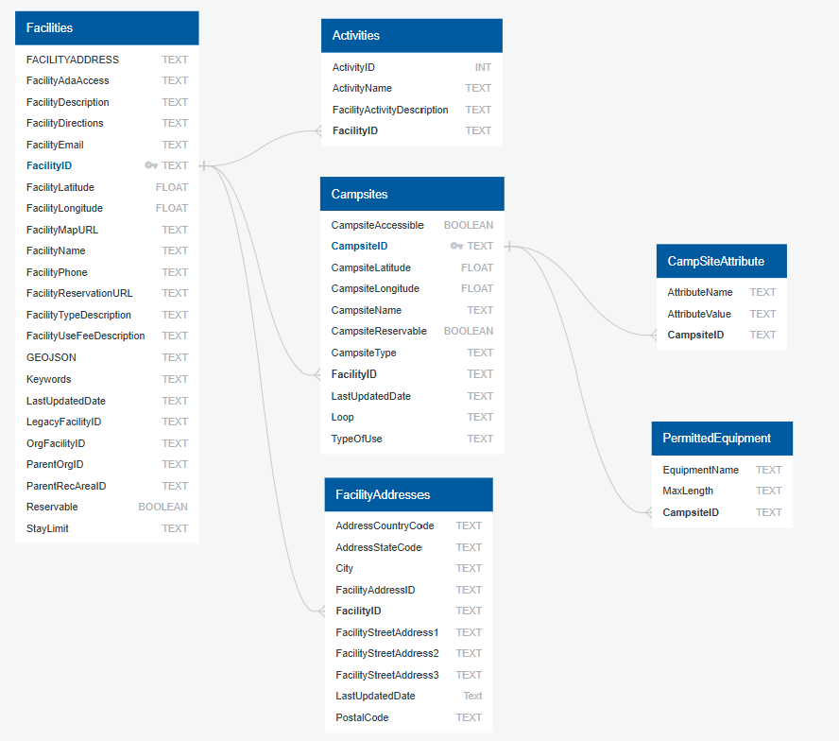

Facility Addresses DataFrame: 1018

Facilities DataFrame: RangeIndex: 848

Activities DataFrame: RangeIndex: 5105

Campsites DataFrame: RangeIndex: 9131

Campsite Attributes DataFrame: RangeIndex: 173616

Permitted Equipment DataFrame: RangeIndex: 29394

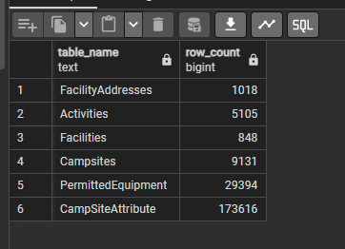ilityAdd

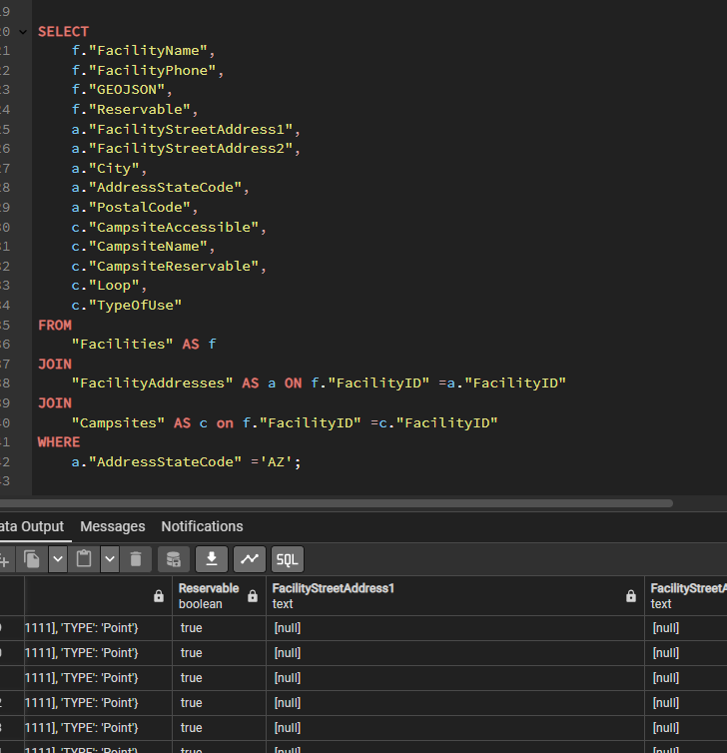

API_LORD_PGDB is complete and tested. We are getting an HTML interface to see all APIs with executable links that return JSON responses for all endpoints.